Hybrid Deep Learning Approach for Prediction of Kidney Stones

Anushya S

Department of Biotechnology, KIT – Kalaignarkarunanidhi Institute of Technology, Coimbatore, Tamil Nadu, India
kit28.24bbt005@gmail.com

Gopinath S

Department of Biotechnology, KIT – Kalaignarkarunanidhi Institute of Technology, Coimbatore, Tamil Nadu, India
kit28.24bbt018@gmail.com

Dr. Tha. Thayumanavan

Professor & Head, Department of Biotechnology, KIT – Kalaignarkarunanidhi Institute of Technology, Coimbatore, Tamil Nadu, India
thayumanavan.tha@gmail.com

Sujitha Shruthika S

Department of Biotechnology, KIT – Kalaignarkarunanidhi Institute of Technology, Coimbatore, Tamil Nadu, India
kit28.24bbt048@gmail.com

Abstract – Kidney stone disease (nephrolithiasis) is one of the most frequently occurring conditions for which timely and effective image-based screening could play a substantial role in the diagnostic process. In this paper, a deep learning-based hybrid architecture is proposed that uses a combination of a Convolutional Neural Network (CNN) and Vision Transformer (ViT) for the binary classification of images of kidneys into two categories: "kidney stone" and "normal". The CNN path performs feature extraction based on localized spatial features such as edges and textures while ViT path uses self-attention mechanism to establish relations throughout the whole image. Predictions of both paths are combined using equal-weight hybrid ensembling. Experiments were conducted using a dataset of 1,801 CT and ultrasound kidney images sourced from Kaggle after resizing, normalization, and augmentation. The accuracy was 88.93% for CNN, 92.62% for ViT, and 94.46% for the hybrid model, and the latter achieved the highest precision (94.71%), recall (94.46%), F1-score (94.43%), and ROC AUC score (~0.992). Therefore, the results suggest that the combination of local convolutional and global transformer-based features significantly improves classification and the model can be used as a screening tool for physicians.
Keywords- kidney stone detection, deep learning, CNN, Vision Transformer, hybrid ensemble learning approach, medical image classification.

I. Introduction
Nephrolithiasis, also referred to as kidney stones, is one of the most common urological diseases across the globe, and their frequency has increased due to many reasons such as unhealthy dieting, lack of water consumption, and many others [1]. Kidney stones if not diagnosed at the right time can lead to complications like obstruction, infection, and kidney injury; hence it becomes very crucial to detect them on time [1], [2]. The two main imaging modalities utilized to diagnose the stones include computed tomography (CT) scan and ultrasound imaging; however, CT imaging provides better anatomical information with the drawback of high radiation doses [2]. Radiologist’s manual assessment of these images takes time and is prone to inconsistencies.

The deep learning techniques have shown themselves to be a valid option for this kind of task because neural networks are able to learn visual discriminating features from images without creating any rule set manually. Convolutional Neural Network (CNN) is known to be one of the best choices when we talk about learning local spatial patterns such as edges, textures, etc., which will help us distinguish the disease based on medical images [3], [4]. Nevertheless, CNNs have some limitations regarding their receptive field and they may not take into account distant parts of an image. This problem can be solved by using the Vision Transformer (ViT) model which is capable of splitting the image into patches and analyzing them using self-attention mechanism in order to find the links between distant parts of the image [6], [8]. The complementary nature of CNN and ViT makes these models suitable to be used in an ensemble [9], [10].
This paper describes the design and evaluation of a hybrid model based on CNN and ViT techniques, which classifies kidney scan images into two classes, namely “kidney stone” and “normal.” The two models are individually trained and evaluated before they are incorporated into a hybrid model, and the three models are analyzed using accuracy, precision, recall, F1-score, confusion matrix analysis, ROC analysis, and correlation analysis. The aim of this paper is to develop a reliable and interpretable support tool that can aid radiologists and clinicians in kidney stones detection.
II. Literature Review
The diagnosis of urolithiasis has been well explored using computer-assisted approaches utilizing CT scanning due to the anatomically rich information provided by CT scans as well as the ability of CT scans to detect even small stones, although the manual analysis of a large volume of CT scans may be quite tiring [2], [5]. This has resulted in the development of an automatic pipeline to detect stones assisted with artificial intelligence (AI). In one such attempt, Parakh et al. have employed a cascaded convolutional neural network to identify stones in non-contrast abdominopelvic CT images and have shown that a CNN can indeed help in diagnosing urolithiasis [3]. A more step forward in this respect has been done by Yildirim et al., who have trained a model for deep learning using 1,799 coronal CT images of 433 subjects and obtained excellent results [4].
Vision transformers offer a new paradigm for representation of the images; the image is partitioned into patches of fixed size, each of which is then embedded, followed by transformer encoder layers which utilize multi-head self-attention for modeling the interaction between the patches [6]. Choi et al. used ViT-based architecture for analysis of high resolution CT images for urolithiasis detection and showed that larger backbone transformers perform better at urolithiasis detection [8]. Similarly, Kim et al. developed an AI system for urolithiasis from CT using deep learning [9].
Since CNNs and transformers represent complementary types of local and global feature learning, some recent studies have considered their hybridizations. For example, Alshenaifi et al. have introduced an AI-powered architecture that fuses CNNs and transformers for detecting kidney stones using CT images [10]; meanwhile, Alzughaibi et al. have used a Vision Transformer together with an ensemble of deep learning models to increase the accuracy of the detection task [11]. Some recent research has been devoted to proposing two-stage approaches capable not only of detecting but also classifying stones according to their clinical severity [12], hybrid CNN-based architectures for classification on the basis of CT images [13], as well as direct comparison between CNNs and Vision Transformers for the kidney stone classification problem [14]. All these works can serve as motivation for considering the hybrid CNN-ViTs approach applied in this study when a CNN branch and a ViT branch are compared on one dataset.
III. Dataset and Preprocessing
A. Dataset Description
The dataset employed in this work is the Kidney Stone Dataset that is publicly available from Kaggle [15] and created by Md. Syed Ahmmed. This dataset consists of 1,801 kidney scan images captured through CT and ultrasound scans, which are classified into two categories – "kidney stone" and "normal." Therefore, the problem to be solved using this data set is supervised binary classification. It should be noted that similar to other medical imaging datasets, the data is imbalanced and can result in bias towards one of the classes when not properly dealt with; this was taken into consideration when preprocessing and evaluating the models. The images are viewed in this project as an arbitrary classification benchmark rather than a multi-center clinical cohort.
B. Image Preprocessing
Prior to the training process, all images were rescaled to a common spatial resolution that is suitable for processing by both the CNN and ViT architectures, as well as normalized to decrease variance. For better generalization of the trained models, augmentation was performed on the training images using random rotation, flipping, and zooming. Such augmentation increases the visual variation of the training images without any extra data collection [10], [11]. After the preprocessing step, the data was split into two subsets, one used for training and the other for testing purposes. This allows us to estimate the performance of the trained models on unseen images. The workflow used in this work is presented in Fig. 1.

Data set collection

Preprocessing

Data Augmentation
(Flip, Zoom)

Model Selection
(CNN + ViT)

Feature Extraction

Hybrid Model Design
(Ensemble Integration)

Training Strategy
(Optimization)

Fig. 1. Pipeline of the hybrid CNN-Vision Transformer architecture for kidney stones classification.

IV. Proposed Hybrid Deep Learning Method
A. Overview of the Proposed Method
The kidney stone detection system based on medical imaging employs two types of architectures that complement each other in detecting the kidney stones, which are the CNN architecture and the ViT architecture. CNN architecture has the ability to detect details in an image locally, whereas the ViT architecture detects the global context of the image. The input images are fed separately into the two branches of the proposed system; the output of each architecture is combined in a hybrid ensemble stage to make a classification decision.
B. Convolutional Neural Network Branch
The CNN module hierarchically extracts features using convolution and pooling. The lower layers recognize primitive features like edges and intensity differences, whereas the deeper layers recognize high-level structural patterns useful for recognizing stones [3], [4]. Reduction in spatial dimensions (pooling operations) helps reduce the size of the feature maps while increasing the effective receptive field of the network, and finally the resultant feature map is mapped to the output class labels.
C. Vision Transformer Branch
The ViT branch encodes an input image as a series of patches of the same size. The patches are then flattened into embeddings, and positional embeddings are appended so that the model keeps the information about the position of each patch inside the original image. The embeddings are fed into the transformer encoder blocks, which perform self-attention computations using
Attention(Q, K, V) = softmax(QK^{T}/√d) V (1)
where Q, K, and V represent the query, key, and value matrices that have been extracted from the patches’ embeddings and d is the scaling factor. This approach enables the ViT branch to connect information coming from distant parts of the image, while on the other hand, the CNN branch works more locally [6].
D. Feature Extraction and Representation
Feature extraction decides what role the branches play in the decision. In this case, the CNN branch deals with local features such as edges, textures, and structure of stones, whereas the ViT branch takes into account global features based on attention over the entire image [3], [6]. The combination of both feature representations allows the hybrid model to process information that could not be processed effectively by any branch individually.
E. Hybrid Ensemble Design
Denote PCNN and PViT as the probability scores computed for the classes using CNN and ViT models, respectively. The combined prediction score is given by
P_{Hybrid} = f(P_{CNN}, P_{ViT}) (2)
where f is the fusion function used for fusing the two branches. In this experiment, the outputs of CNN and ViT branches are averaged (ensemble in a 50%–50% manner), and the predicted class label is selected based on the output probability value after fusing. This averaging method is an efficient way to fuse two predictions while mitigating errors made by one of the two branches [9], [11].
F. Training Strategy
Both models were then trained on the labeled training dataset and tested on the testing dataset that was not seen by the model at all during the training process. Training was done according to the normal procedure for supervised learning, which involved forward propagation of the image data, comparison of the probability prediction to the actual label, and updating the network's weights using the backpropagation method. Batch training, proper learning rate scheduling, and validation were carried out in order to avoid overfitting and to ensure generalization [4], [10].
G. Evaluation Metrics
Model performance was evaluated using accuracy, precision, recall, and F1-score, which are common measures of performance in classification problems for medical imaging applications [3], [12]. The accuracy is defined as the total ratio of correctly classified images; precision is calculated by counting the number of “kidney stone” examples that are truly positive cases; recall is computed by counting the number of truly positive cases which have been correctly classified as such; and F1 score calculates the balance between precision and recall. The confusion matrix is another measure that allows us to understand the class-wise mistakes in classification, while ROC analysis evaluates classification discrimination..
V. Results and Discussion
A. Model Performance
The accuracy of each of the three setups is given in Table I below. The accuracy for the CNN model was 88.93%, for the ViT was 92.62%, while the highest accuracy was that of the hybrid ensemble which was 94.46%, 5.53 percentage points higher than the accuracy of CNN alone and 1.84 percentage points higher than ViT alone. This trend shows a clear reflection of the expected outcome of the hybrid model because the two models complement each other well in their areas of strength.
TABLE I. COMPARISON OF ACCURACY OF THE MODELS UNDER
S.No. | Model | Accuracy
1 | CNN | 88.93%
2 | ViT | 92.62%
3 | Hybrid CNN–ViT | 94.46%

B. Confusion Matrix Analysis
Fig. 2-4 depict the confusion matrices that were generated for the CNN, ViT, and hybrid models, respectively, for the test dataset. The CNN model achieved a classification accuracy of 91% for 108 out of 119 kidney-stone cases and 88% for 133 out of 152 normal cases (Fig. 2), which translates to an overall accuracy of 88.93%. The ViT model achieved a classification accuracy of 83% for 99 out of 119 kidney-stone cases, but all 152 normal cases were correctly classified by it, resulting in a 100% accuracy for the normal case class (Fig. 3). However, this was achieved at the cost of generating more false positives for the stone class. The hybrid model achieved a classification accuracy of 89% for 106 out of 119 kidney-stone cases and 99% for 150 out of 152 normal cases (Fig. 4). This model achieved a much better distribution in terms of both classes compared to the CNN model.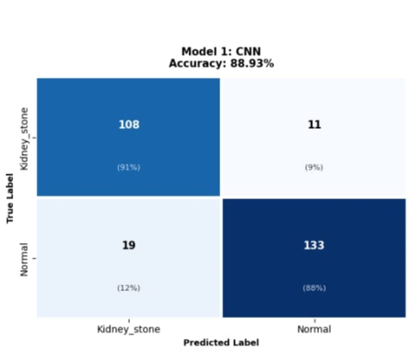

Fig. 2. Confusion matrix of the CNN model.
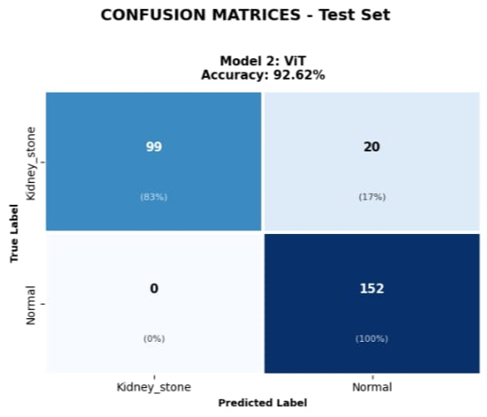
Fig 3. The confusion matrix of ViT model.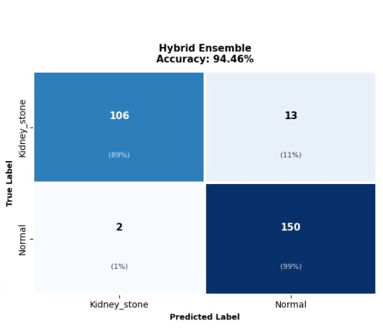
Fig. 4. Confusion matrix for hybrid CNN-ViT ensemble model.

C. ROC Curve Analysis
Figure 5 shows the ROC curve for the hybrid ensemble, showing the true positive rate plotted against the false positive rate along the decision threshold. The curve shows a high steepness towards the top left and produces a value of area under the curve of approximately 0.992. This indicates that the hybrid classifier provides good discrimination between cases of kidney stone and the normal category over almost all the ranges of threshold used. This should be taken together with the accuracy and F1-scores discussed above.
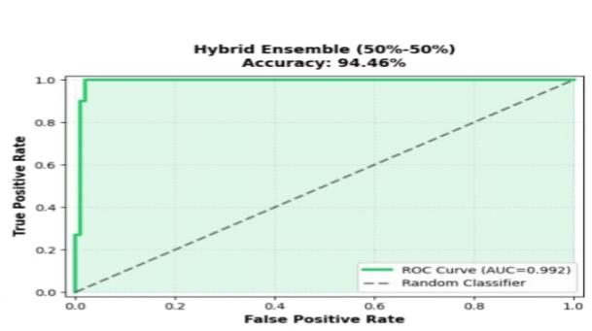

Fig. 5. ROC curve of the 50%–50% ensemble (AUC = 0

D. Precision, Recall, and F1-Score
The precision, recall, and F1 score of all three models are shown in Table II. The CNN was able to get 88.15% precision, 88.93% recall, and 88.96% F1 score. ViT surpassed all three measures with 93.48% precision, 92.62% recall, and 92.51% F1 score. Hybrid ensemble was better than the rest with 94.71% precision, 94.46% recall, and 94.43% F1 score. This proves that the hybrid ensemble.

TABLE II. COMPARE PRECISION, RECALL, AND F1

S.No. | Model | Precision | Recall | F1-score
1 | CNN | 88.15% | 88.93% | 88.96%
2 | ViT | 93.48% | 92.62% | 92.51%
3 | Hybrid | 94.71% | 94.46% | 94.43%

E. Correlation Analysis
Fig. 6-8 provide the heat maps of the correlation-prediction between the three models used in the research. In Fig. 6, which represents the heat map for the CNN model, the correlation value is 0.91 for the kidney-stone category and 0.88 for the normal category. For the heat map in Fig. 8, representing the hybrid model, the correlation value is approximately 0.89 for the kidney-stone category and 0.99 for the normal category, showing a very high correlation between the predicted values and the actual values especially in the normal category.
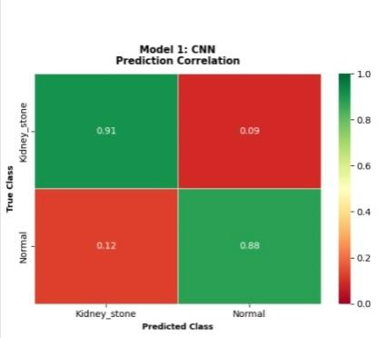
Fig. 6. Prediction-correlation heatmap for the CNN model.
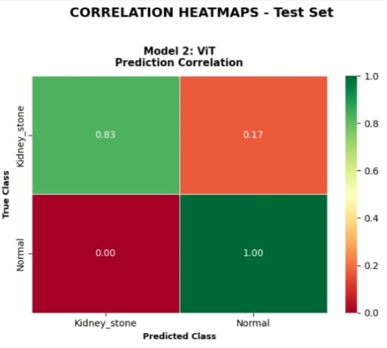
Fig. 7. Prediction correlation heatmap of ViT model.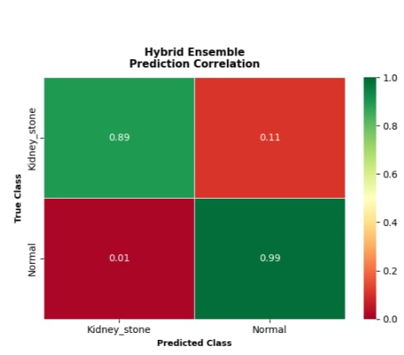
Fig. 8. Prediction-Correlation Heat Map of the CNN-ViT Ensemble Model
.VI. Comparative Analysis with Existing Methods
Previous CNN-based works have proven the efficacy of using convolutional networks to extract spatially local features like edges and small structures in kidney CT images [3], [4], [5]; however, they may face difficulties in modeling the relationship between distant areas of the image. Vision Transformers (ViTs) have overcome this shortcoming using self-attention and recent works have used ViTs for CT-based kidney stone detection [6], [8], [9]. Another set of literature includes hybrid and ensemble architectures, two-step pipelines (detection followed by grading), and head-to-head comparison of CNNs and ViTs, which show the trend of combining representation learning techniques instead of just using one of the model families [10], [11], [12], [13], [14].
The proposed hybrid model in this paper is based on the same principle as well, which uses the CNN branch for the extraction of local features and the ViT branch for modeling the dependencies in the global space. In the current experiment setup, the accuracy of the hybrid model (94.46%) outperforms that of both the CNN (88.93%) and the ViT (92.62%) models under the same conditions. As the data sets, imaging techniques, preprocessing methods, and evaluation metrics used in different experiments may vary from each other, it is better to consider the above mentioned results only in the context of the current experiment.
VII. Limitations
There are various limitations that exist in this study, which need to be kept in mind while analyzing the findings. To start with, the dataset being used in the study is the publicly available image set rather than a clinical cohort of independent data from different centers; thus, the accuracy achieved in the study is limited to the performance in the given dataset and not clinical generalizability. Next, the analysis is not exhaustive in terms of capturing all the training hyperparameters, such as optimizer information and exact learning rate. Thirdly, since the dataset is analyzed at the image level, it might be different when compared to patient-level analysis as there could be multiple images belonging to the same patient.
VIII. Conclusion
The proposed study has discussed the development of a hybrid deep learning framework using a CNN branch and a ViT branch for binary classification of kidney scan images into stone and non-stone categories. While the former focuses on capturing local spatial and textural features of images, the latter is involved in capturing global relations between various parts of the images by the way of self-attention; both the CNN and ViT branches produce their respective feature outputs that are further averaged to produce the final output of the hybrid ensemble with equal weights. When tested on a data set containing 1,801 kidney scan images, the accuracy achieved by the CNN, ViT, and hybrid models was 88.93%, 92.62%, and 94.46%, respectively, while the hybrid model also had the highest precision (94.71%), recall (94.46%), F1-score (94.43%), and ROC AUC (approximately 0.992). The findings reveal that the combination of local features with global context based on transformers can enhance the performance of classification of kidney stones on the particular data set. However, the findings are specific to the data set.
IX. Future Scope
A few areas for potential extensions can be identified here. For instance, it would be useful to train and test the framework on larger datasets and with patient-level splits instead of only using image-level splits to examine the generalization capability of the model [5], [12]. It might be helpful to tune further the architectures of the CNN and ViT and conduct ablation studies for the fusion approach to improve the feature extraction capability and classification results [10], [11]. The implementation of explainable-AI methods would allow understanding which image parts are responsible for predictions made by the model and developing clinicians' trust in its results [9], [12]. Additionally, the computational cost reduction of the proposed hybrid framework is necessary for making it more applicable in practice [12]. Furthermore, the extension of the architecture to the other conditions related to kidneys besides stone detection is possible.

References
[1] C. D. Scales Jr., A. C. Smith, J. M. Hanley, and C. S. Saigal, “Prevalence of kidney stones in the United States,” European Urology, vol. 62, no. 1, pp. 160–165, 2012, doi: 10.1016/j.eururo.2012.03.052.
[2] R. Smith-Bindman et al., “Ultrasonography versus computed tomography for suspected nephrolithiasis,” New England Journal of Medicine, vol. 371, no. 12, pp. 1100–1110, 2014, doi: 10.1056/NEJMoa1404446.
[3] A. Parakh, H. Lee, J. H. Lee, B. H. Eisner, D. V. Sahani, and S. Do, “Urinary Stone Detection on CT Images Using Deep Convolutional Neural Networks: Evaluation of Model Performance and Generalization,” Radiology: Artificial Intelligence, vol. 1, no. 4, e180066, 2019, doi: 10.1148/ryai.2019180066.
[4] K. Yildirim, P. Gundogan Bozdag, M. Talo, O. Yildirim, M. Karabatak, and U. R. Acharya, “Deep learning model for automated kidney stone detection using coronal CT images,” Computers in Biology and Medicine, vol. 135, Art. no. 104569, 2021, doi: 10.1016/j.compbiomed.2021.104569.
[5] “An Effective Deep Learning Approach for Kidney Stone Detection in CT Scan Images using Convolutional Neural Network,” in 2024 IEEE Int. Conf. on Computing, Applications and Systems (COMPAS), 2024, doi: 10.1109/COMPAS60761.2024.10797179.
[6] A. Dosovitskiy et al., “An Image is Worth 16×16 Words: Transformers for Image Recognition at Scale,” in Int. Conf. on Learning Representations (ICLR), 2021.
[7] D. C. Elton, E. B. Turkbey, P. J. Pickhardt, and R. M. Summers, “A deep learning system for automated kidney stone detection and volumetric segmentation on non-contrast CT scans,” Medical Physics, vol. 49, no. 4, pp. 2545–2554, 2022, doi: 10.1002/mp.15518.
[8] H. S. Choi, J. S. Kim, T. K. Whangbo, and S. J. Eun, “Improved Detection of Urolithiasis Using High-Resolution Computed Tomography Images by a Vision Transformer Model,” International Neurourology Journal, vol. 27, Suppl. 2, pp. S99–S103, 2023, doi: 10.5213/inj.2346292.146.
[9] J. Kim et al., “A Novel Deep Learning-based Artificial Intelligence System for Interpreting Urolithiasis in Computed Tomography,” European Urology Focus, vol. 10, no. 6, pp. 1049–1054, 2024, doi: 10.1016/j.euf.2024.07.003.
[10] R. Alshenaifi, Y. Alqahtani, S. M. Aslam, and U. Snekhalatha, “AI-driven framework for automated detection of kidney stones in CT images: integration of deep learning architectures and transformers,” Biomedical Physics & Engineering Express, vol. 11, no. 5, 2025, doi: 10.1088/2057-1976/adf3ba.
[11] A. Alzughaibi, A. A. Alanazi, M. Alshahrani, I. H. Jaghdam, and A. A. Hassaballa, “Synergizing vision transformer with ensemble of deep learning model for accurate kidney stone detection using CT imaging,” Alexandria Engineering Journal, vol. 127, pp. 357–373, 2025, doi: 10.1016/j.aej.2025.05.025.
[12] “A two-stage deep learning framework for kidney stone detection and clinical severity grading in CT imaging,” Informatics in Medicine Unlocked, vol. 59, Art. no. 101704, 2025, doi: 10.1016/j.imu.2025.101704.
[13] “Classification and Detection of Kidney Stone Using Hybrid CNN Model on CT Images,” in 2025 3rd Int. Conf. on Advances in Computation, Communication and Information Technology (ICAICCIT), 2025, doi: 10.1109/ICAICCIT68829.2025.11434296.
[14] A. A. Hafiz, D. Vericho, V. J. Carter, D. C. Thio, M. Isnan, and B. Pardamean, “Vision Transformer and CNNs in Kidney Stone Classification: A Comparative Study,” Procedia Computer Science, vol. 269, pp. 1466–1473, 2025, doi: 10.1016/j.procs.2025.09.088.
[15] M. S. Ahmmed, “Kidney Stone Dataset,” Kaggle. [Online]. Available: https://www.kaggle.com/datasets/mdsyedahmmed/kidney-stone-dataset/data. Accessed: Sep. 4, 2026.

